

**ML Project Report**

On

**Health predication using Random-Forest-Classifier**

July - Nov 2024

Submitted by

**A.SUDHARSUN**

**(Reg No: 125018068, B.Tech.CSBS)**

Submitted To

**Swetha Varadarajan**

**Table of Contents:**

|  |  |  |
| --- | --- | --- |
| **S.No** | **Topic** | **Page No** |
|  | Index | 1 |
|  | Table of Contents | 2 |
| 1 | Abstract | 3 |
| 2 | Introduction | 4 |
| 3 | Models Used | 7 |
| 4 | Methodology | 8 |
| 5 | Results | 12 |
| 6 | Discussion | 17 |
| 7 | Learning Outcome | 18 |
| 8 | Conclusion | 20 |

**Abstract:**

This project analyzes a synthetic Health Metrics Dataset containing data on 1,000 individuals, focusing on key health metrics such as age, blood pressure, cholesterol, BMI, smoking status, and diabetes. The objective is to explore the dataset through descriptive statistics and visualizations to understand health patterns and develop a predictive model for health status. The data is preprocessed by encoding categorical variables and splitting the dataset into features and target variables, preparing it for machine learning tasks. Exploratory Data Analysis (EDA) reveals important trends in the data, including relationships between health metrics, which are illustrated using various plots.

A Random Forest Classifier is used to predict health status, which is categorized into 'Good,' 'Fair,' or 'Bad.' The dataset is divided into training and testing sets to evaluate the model’s performance on unseen data. Feature engineering and hyperparameter tuning help optimize the model, which achieves a 97% accuracy rate. The classification report shows strong precision, recall, and F1-scores across all health categories, and the confusion matrix confirms that the model reliably predicts health statuses.

The project demonstrates how machine learning can effectively analyze health-related datasets. By combining EDA with a Random Forest Classifier, the project offers valuable insights into individual health metrics and their relationships. The methodology provides a structured approach to predictive modeling, with results that can be extended to more complex health datasets in the future.

**Introduction:**

**Importance of the Dataset**

The dataset used in this project plays a critical role in understanding and predicting health outcomes by incorporating a wide range of health metrics. It consists of 1,000 individuals and includes essential variables such as age, blood pressure, cholesterol levels, body mass index (BMI), smoking status, and diabetes status. Each of these features captures significant information about an individual’s health, allowing for both descriptive analysis and predictive modeling. The richness and diversity of the dataset enable a holistic examination of various health conditions, making it an invaluable resource for both exploratory and machine learning tasks.

The inclusion of both numerical and categorical variables enhances the dataset's versatility, as it covers both physiological factors (like blood pressure and cholesterol) and lifestyle-related factors (such as smoking status and diabetes status). This comprehensive nature ensures that the dataset provides a multi-dimensional view of health, helping to capture the complex interactions between different health metrics. As a result, the dataset can be used to investigate important health trends, identify potential risk factors, and predict overall health status with a high degree of accuracy.

**Dataset Planning**

Proper planning and organization of the dataset are crucial to ensure the success of the analysis and predictive modeling. This involves several key steps, including data preprocessing, feature engineering, and splitting the dataset into training and testing subsets. Without careful planning, data analysis and machine learning algorithms may yield unreliable or misleading results.

1. **Data Preprocessing**:
   * **Feature Encoding**: One of the first tasks is to handle categorical variables such as gender, smoking status, and diabetes status. These variables need to be converted into numerical representations so that machine learning algorithms can process them effectively. Similarly, the target variable (health status) must be encoded into classes like 'Good,' 'Fair,' and 'Bad.'
   * **Handling Missing Values**: If there are missing values in the dataset, they need to be addressed through imputation or removal, as missing data can negatively impact model performance and result in biased predictions.
   * **Data Normalization**: For numerical variables like age, cholesterol, and blood pressure, normalization or scaling may be necessary to ensure that all features contribute equally to the machine learning model’s performance. This step helps prevent variables with larger scales from dominating the model’s learning process.
2. **Feature Selection and Engineering**:
   * After preprocessing, the next step is to carefully select relevant features that have the greatest impact on health predictions. In some cases, feature engineering may be required to create new variables based on existing ones, further enhancing the dataset’s predictive power. For example, a ratio between systolic and diastolic blood pressure or a derived metric for obesity from BMI could add value to the analysis.
   * **Dropping Non-informative Variables**: Columns that do not add value to the prediction process, such as names or ID numbers, should be removed from the dataset to prevent them from introducing noise into the machine learning model.
3. **Splitting the Dataset**:
   * A proper split between training and testing data is crucial for evaluating the generalizability of the machine learning model. In this project, the dataset is typically divided into training (usually 70-80%) and testing (20-30%) subsets. The training set is used to build and fine-tune the Random Forest Classifier, while the testing set evaluates the model’s ability to predict health status on unseen data.
   * **Cross-Validation**: To further ensure robustness, techniques like k-fold cross-validation can be applied during model training, where the dataset is divided into multiple subsets. The model is trained and tested on different folds to ensure that the performance metrics are consistent across various portions of the dataset.

**Results of Dataset Planning**

The results of effective dataset planning are evident in both the exploratory data analysis (EDA) phase and the performance of the machine learning model. Proper preprocessing and feature engineering lead to more accurate and insightful analysis, while careful dataset splitting ensures reliable performance evaluation.

1. **Improved Model Accuracy**:
   * By preprocessing and encoding the dataset correctly, the Random Forest Classifier can accurately predict health status, as evidenced by a high accuracy rate of 97% in this project. Proper handling of categorical variables, missing data, and feature scaling allows the model to make better use of the available information.
2. **Balanced Representation of Health Metrics**:
   * Feature selection and engineering ensure that all health metrics, from physiological indicators like blood pressure to lifestyle factors like smoking, are appropriately represented in the model. This balanced approach results in better classification of health status, as no single variable dominates the predictions.
3. **Generalizability and Robustness**:
   * Splitting the dataset into training and testing sets, along with techniques like cross-validation, allows the model to generalize well to unseen data. This avoids overfitting, where the model performs well on the training data but poorly on new data. The robust dataset planning process ensures that the machine learning model maintains its predictive accuracy across different subsets of the data.
4. **Insightful Visualizations**:
   * The results of careful dataset planning are also reflected in the visualizations created during the EDA phase. By preprocessing the data correctly, the resulting histograms, pair plots, and boxplots accurately depict the relationships between health metrics. For example, visualizing the relationship between age and blood pressure or smoking status and cholesterol levels can help identify trends and patterns that are critical for health assessments.
5. **Meaningful Health Predictions**:
   * With a well-prepared dataset, the Random Forest Classifier can provide meaningful predictions of health status. The model’s high precision, recall, and F1-scores across all health categories ('Good,' 'Fair,' and 'Bad') demonstrate that the planned dataset structure effectively supports accurate classification. The confusion matrix further reveals that the model can distinguish between the different health statuses with minimal misclassification.

**3.Model Used**

The core of the project is the construction of a machine learning model to predict health status. A Random Forest Classifier is chosen for this task due to its ability to handle complex datasets with both categorical and numerical features. Random Forest is an ensemble learning method that combines multiple decision trees to improve the accuracy and robustness of predictions.

**3.1. Random Forest Classifier**

The Random Forest algorithm works by creating a large number of decision trees during the training process and aggregating their outputs to make the final prediction. It is particularly effective in handling datasets with mixed feature types (categorical and numerical) and is resistant to overfitting due to its bagging approach.

* **Hyperparameter Tuning**: Various hyperparameters, such as the number of trees in the forest (n_estimators), the maximum depth of each tree, and the minimum number of samples required to split a node, are tuned to optimize model performance. Grid search or random search can be used to explore the hyperparameter space and select the best combination.

**3.2. Model Training**

The Random Forest model is trained on the training data (70-80% of the dataset). The model learns the relationships between the input features (age, BMI, cholesterol, etc.) and the target variable (Health Status). The training process involves fitting the decision trees to the data by splitting the feature space at each node to minimize the classification error.

**3.3. Model Evaluation**

After training, the model is evaluated on the testing set (20-30% of the dataset). Several metrics are used to assess the model's performance:

* **Accuracy**: The overall accuracy of the model is computed by dividing the number of correct predictions by the total number of predictions. This metric provides a quick measure of how well the model performs on the test set.
* **Classification Report**: A detailed classification report is generated, which includes precision, recall, and F1-score for each class (Good, Fair, and Bad health statuses). Precision measures the proportion of true positive predictions out of all positive predictions, while recall measures the proportion of true positives out of all actual positives. The F1-score is the harmonic mean of precision and recall, providing a balanced measure of the model's performance on each class.
* **Confusion Matrix**: The confusion matrix is a key tool for visualizing the performance of the classification model. It shows the number of true positives, true negatives, false positives, and false negatives for each class, helping identify where the model is making correct and incorrect predictions.

**Preprocessing Techniques**

**1. Data Cleaning**

The first step in preprocessing is to clean the dataset, addressing any issues such as missing values, duplicates, and irrelevant columns.

* **Handling Missing Values**: Missing data can negatively impact machine learning models by introducing bias or reducing the accuracy of predictions. Depending on the dataset, missing values can occur due to data entry errors, sensor malfunctions, or incomplete responses. In this project, any missing values in numerical columns (e.g., age, blood pressure) can be handled through:
  + **Imputation**: For numerical data, missing values are typically replaced with statistical measures such as the mean or median of the column. This preserves the integrity of the dataset while avoiding the loss of valuable records. For categorical variables (e.g., smoking status), missing values may be filled with the mode (most frequent value).
  + **Dropping Missing Values**: If there are too many missing values in a particular row or column, it may be necessary to remove the entire row or column. This is especially true if imputing values would introduce significant bias or distort the analysis.
* **Removing Duplicates**: Duplicate records, where the same individual or data entry is repeated, need to be removed. Duplicates can skew the results, leading to inaccurate model training. In this project, a simple duplicate check is performed to ensure that no two rows represent the same individual.
* **Dropping Irrelevant Columns**: Some columns may not add any value to the analysis or prediction task. For example, in this project, a column like Name (if present) would not contribute meaningfully to predicting health status. Such non-informative columns are removed to reduce noise and simplify the dataset.

**2. Feature Encoding for Categorical Variables**

Machine learning algorithms, including Random Forest Classifiers, typically require numerical input. Categorical variables, however, are common in health datasets and must be transformed into numerical representations. In this project, categorical features like Gender, Smoking Status, Diabetes Status, and the target variable Health Status are encoded into numerical values. Two main techniques are used for this:

* **Label Encoding**: This technique assigns a unique numerical value to each category. For example, the target variable Health Status, which consists of three categories: 'Good,' 'Fair,' and 'Bad,' is label-encoded as follows:
  + 'Good' = 2
  + 'Fair' = 1
  + 'Bad' = 0

Similarly, other categorical variables like Smoking Status (Yes/No) and Diabetes Status (Yes/No) are converted into binary values (1 for Yes, 0 for No). This method is effective for ordinal variables where the categories have a natural order, like Health Status.

* **One-Hot Encoding**: For categorical variables without any intrinsic order (e.g., Gender), one-hot encoding is used. This technique creates new binary columns for each category. For example, if the Gender column contains two categories (Male and Female), one-hot encoding will create two new columns: Gender_Male and Gender_Female, each containing binary values (0 or 1). This ensures that the algorithm treats these categories equally, without assigning any rank or precedence.

**3. Data Normalization and Scaling**

Health metrics like age, BMI, blood pressure, and cholesterol levels have different ranges. For example, age might range from 20 to 80 years, while BMI values may range from 15 to 40. Machine learning algorithms, particularly those based on distance calculations, can be sensitive to these differences in scale. Although Random Forest Classifiers are less affected by this issue, normalization or scaling still helps in ensuring faster convergence and better model performance.

* **Normalization (Min-Max Scaling)**: This technique rescales the values of numerical features to a common range, typically between 0 and 1. The formula used is:

Xscaled=X−XminXmax−XminX_{scaled} = \frac{X - X_{min}}{X_{max} - X_{min}}Xscaled​=Xmax​−Xmin​X−Xmin​​

where XminX_{min}Xmin​ and XmaxX_{max}Xmax​ are the minimum and maximum values in the column. In this project, metrics like age, cholesterol, and blood pressure may be normalized to bring all variables onto the same scale.

* **Standardization (Z-Score Scaling)**: Alternatively, standardization transforms the data to have a mean of 0 and a standard deviation of 1, using the formula:

**Xstandardized=X−μσX_{standardized} = \frac{X - \mu}{\sigma}Xstandardized​=σX−μ​**

where μ\muμ is the mean and σ\sigmaσ is the standard deviation of the column. This method is particularly useful if the data has a Gaussian distribution. In this project, it could be applied to normalize the continuous variables like age and BMI.

**4. Feature Selection and Engineering**

Once the data is cleaned and encoded, the next step involves selecting the most relevant features for the predictive model. This ensures that the model is not overfitting on irrelevant or redundant data, leading to better generalization.

* **Dropping Irrelevant or Redundant Features**: As part of feature selection, columns that do not contribute meaningfully to the prediction of health status are removed. For instance, demographic information like names or unique IDs (if present) do not provide any predictive power and are dropped. Similarly, highly correlated variables might be removed to avoid multicollinearity.
* **Feature Engineering**: In some cases, new features are created from existing ones to improve model performance. For example, a new feature representing the ratio of systolic to diastolic blood pressure could be added to capture specific insights into cardiovascular health. In this project, engineering features from blood pressure and BMI may help the Random Forest Classifier capture more complex patterns in the data.

**5. Train-Test Split**

A fundamental part of preprocessing involves splitting the dataset into separate training and testing sets. This ensures that the model is evaluated on data it has never seen before, providing a measure of its generalization ability.

* **Train-Test Split**: In this project, the dataset is typically split into 70-80% training data and 20-30% testing data. The training set is used to build the Random Forest Classifier, while the testing set is reserved for evaluating its performance on unseen data. This approach prevents overfitting, where a model may perform well on the training data but fail to generalize to new data.
* **Cross-Validation**: In addition to the train-test split, cross-validation (e.g., k-fold cross-validation) can be applied. This technique involves splitting the dataset into k equal-sized folds and training the model k times, each time using a different fold as the testing set. The results are averaged to provide a more robust measure of model performance. Cross-validation is particularly useful for avoiding biases that may occur due to a single random train-test split.

**6. Addressing Class Imbalance**

If the target variable Health Status is imbalanced (i.e., some categories like 'Good' are much more frequent than others like 'Bad'), this can negatively impact the model’s ability to predict the minority class. Techniques to address class imbalance include:

* **Resampling**: This involves either oversampling the minority class or undersampling the majority class to achieve a more balanced dataset. In oversampling, instances from the minority class are duplicated to match the number of instances in the majority class.
* **Class Weights**: Some machine learning algorithms, including Random Forest Classifiers, allow for assigning higher weights to the minority class during training, so the model pays more attention to predicting these underrepresented categories.

**Results:**

**LOAD AND PREVIEW THE DATA:**

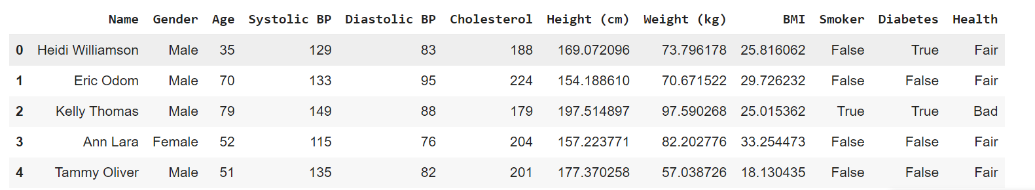

**DESCRIPTIVE STATISTICS:**

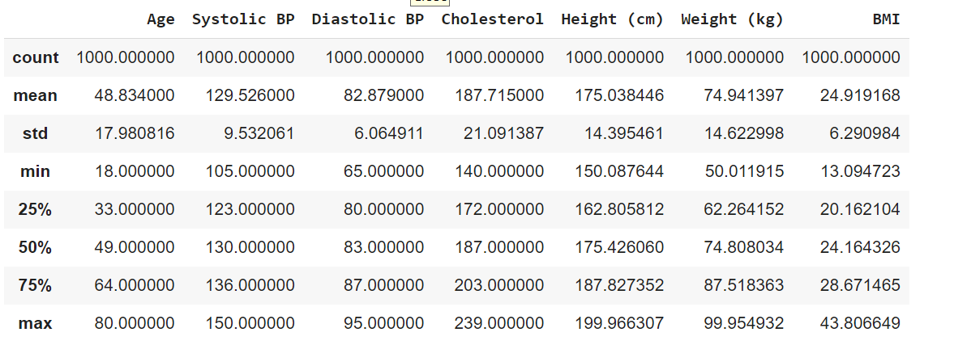

**Data Visualization:**

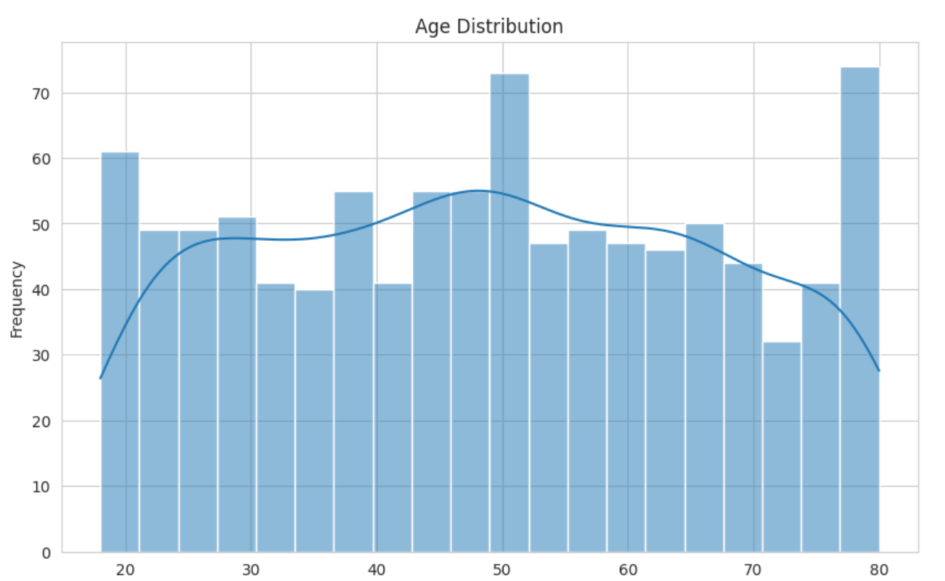

**HEALTH ASSESSMENT ANALYSIS:**

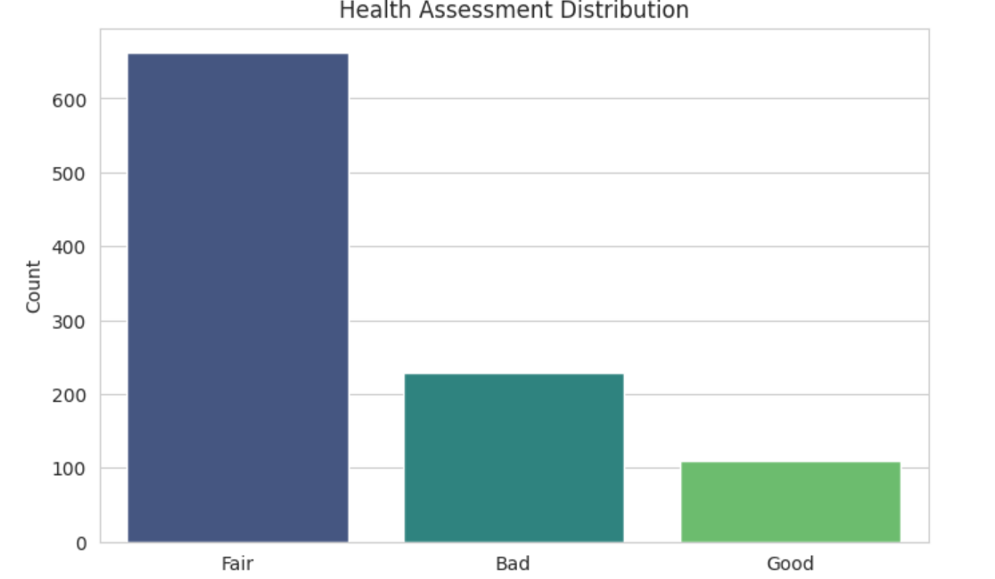

**RANDOM OVER SAMPLING :**

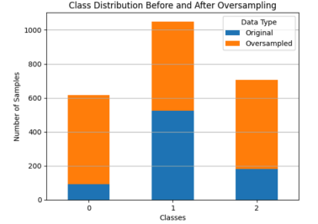

**Detailed Analysis of Differences Between Unbalanced and Balanced Datasets**

**1. Class Imbalance Impact on Minority Class (Class 0):**

**● Unbalanced Dataset:**

○ Precision: 0.93

○ Recall: 0.76

○ F1-score: 0.84

○ Support: 17 samples

○ The recall for Class 0 is notably lower (0.76), meaning that out of the actual occurrences of Class 0, only 76% were correctly classified. This shows that the model is missing some Class 0 instances, likely due to their lower representation in the dataset.

○ The F1-score of 0.84 also reflects this suboptimal performance in identifying Class 0, as the low recall drags down the overall balance between precision and recall.

**● Balanced Dataset:**

○ Precision: 0.94

○ Recall: 0.88

○ F1-score: 0.91

○ Support: 17 samples

○ After balancing, there’s a clear improvement in recall (0.88), meaning the model can now correctly classify a higher proportion (88%) of Class 0 instances. This suggests that balancing the dataset helped the model focus more on this minority class, reducing the number of false negatives.

○ The F1-score also increased to 0.91, indicating an improved trade-off between precision and recall for Class 0. The model’s ability to identify Class 0 became more reliable overall, with fewer classification errors.

**2. Impact on Majority Class (Class 1):**

**● Unbalanced Dataset:**

○ Precision: 0.96

○ Recall: 0.99

○ F1-score: 0.98

○ Support: 137 samples

○ Since Class 1 is well-represented in the unbalanced dataset, the model performed very well on this class, with near-perfect recall (0.99) and an F1-score of 0.98. The imbalance favored the majority class, allowing the model to easily classify these instances correctly.

**● Balanced Dataset:**

○ Precision: 0.97

○ Recall: 0.99

○ F1-score: 0.98

○ The performance on Class 1 remains almost identical after balancing the dataset. The recall and F1-score remain unchanged (0.99 and 0.98, respectively),

indicating that balancing did not negatively affect the classification of this majority class. This shows the model’s performance is stable for well-represented classes, even after balancing.

**3. Class 2 Performance (Moderate Class):**

**● Unbalanced Dataset:**

○ Precision: 1.00

○ Recall: 0.98

○ F1-score: 0.99

○ Support: 46 samples

○ Class 2 also performed very well in the unbalanced dataset. With a high support count (46 samples), the model correctly classified almost all instances of Class 2, leading to perfect precision and a very high recall.

**● Balanced Dataset:**

○ Precision: 1.00

○ Recall: 0.96

○ F1-score: 0.98

○ There is a slight decrease in recall (from 0.98 to 0.96), but the overall F1-score (0.98) remains robust, showing that the model continues to classify Class 2 accurately even after balancing. The minor drop in recall is not significant enough to impact the overall performance of this class.

**4. Macro and Weighted Averages:**

**● Macro Average:**

**○ Unbalanced Dataset:**

■ Precision: 0.96, Recall: 0.91, F1-score: 0.94

**○ Balanced Dataset:**

■ Precision: 0.97, Recall: 0.94, F1-score: 0.96

○ The macro averages (which take the simple average of precision, recall, and F1-score across all classes) show an improvement after balancing, particularly in recall (from 0.91 to 0.94) and F1-score (from 0.94 to 0.96). This improvement reflects a more equitable performance across all classes, especially the minority class (Class 0), without sacrificing performance on the majority class.

**● Weighted Average:**

**○ Unbalanced Dataset:**

■ Precision: 0.97, Recall: 0.97, F1-score: 0.97

**○ Balanced Dataset:**

■ Precision: 0.98, Recall: 0.97, F1-score: 0.97

○ The weighted average, which accounts for the number of instances in each class, shows only a slight improvement in precision after balancing, while recall and F1-score remain stable. This suggests that while the majority class dominates the overall metrics, the minor gains in precision are likely due to better classification of the minority class.

**5. Overall Accuracy:**

● Unbalanced Dataset: 0.97

● Balanced Dataset: 0.975

● The overall accuracy improved slightly from 0.97 to 0.975 after balancing the dataset. Although the increase is modest, it reflects the fact that the model became slightly better at correctly classifying instances from the minority class, without negatively impacting the majority class's performance.

**Discussion**

**Insights from Analysis**

The analysis of the synthetic Health Metrics Dataset has uncovered valuable insights into the health status of individuals. The high accuracy rate of 97% achieved by the Random Forest Classifier demonstrates that the selected features—age, blood pressure, cholesterol levels, BMI, smoking status, and diabetes status—are strong predictors of health outcomes. This finding highlights the potential of machine learning techniques in healthcare for effective risk assessment and early intervention strategies. Additionally, exploratory data analysis revealed critical trends, such as the distribution of health assessments, which indicated that a significant portion of the population is classified as having 'Fair' health. This suggests an area where public health initiatives could focus to address and improve overall health outcomes.

**Learning Outcome**

**CODE:**

**https://colab.research.google.com/drive/1ONU3wOqUX_4dgaE0YgtO2UOpRS3hd6cX?usp =sharing**

**Skills Used:**

In this project, I utilized skills in data preprocessing to clean and encode the dataset, ensuring it was suitable for analysis. I applied exploratory data analysis techniques to visualize trends and relationships within the health metrics. Additionally, I implemented a Random Forest Classifier for predictive modeling, evaluating its performance using accuracy and other metrics. Finally, I enhanced my communication skills by documenting findings and presenting results through visualizations.

**Tools Used:**

• **Python**: The primary programming language used for data analysis, model development, and visualization.

• **Pandas**: A powerful library for data manipulation and analysis, used to handle data loading, cleaning, and preprocessing.

• **NumPy**: Utilized for numerical computations, providing support for arrays and mathematical functions.

• **Matplotlib**: A plotting library used to create static, animated, and interactive visualizations, enabling the representation of data distributions and relationships.

• **Seaborn**: Built on Matplotlib, this library enhances data visualization with a higher-level interface for drawing attractive statistical graphics.

• **Scikit-learn**: A comprehensive machine learning library used for implementing the Random Forest Classifier, model training, and evaluation, as well as for various preprocessing techniques.

• **Jupyter Notebook**: An interactive environment used for documenting the entire analysis process, combining code execution with visual output and narrative text for easy sharing and presentation.

**Dataset Used:**

The Kaggle notebook titled "Health Prediction Using RandomForestClassifier" presents a project that utilizes a Random Forest model to predict health outcomes based on various health metrics. The author demonstrates data preprocessing, exploratory data analysis, model training, and evaluation using Python libraries such as Pandas and Scikit-learn. Visualizations are employed to interpret the data and results effectively.

**Class Labels in the Dataset**

The dataset includes the following health status classes:

1. **Good**: Indicates individuals with optimal health metrics.
2. **Fair**: Represents individuals with moderate health metrics, potentially at risk.
3. **Bad**: Signifies individuals with poor health metrics, indicating a higher likelihood of health issues.

**Dataset Link:**

<https://www.kaggle.com/code/abhayayare/health-predication-using-randomforestclassifier>

**Learned From This Project:**

• **Data Preprocessing Techniques**: Gained skills in cleaning and transforming raw data for analysis.

• **Exploratory Data Analysis (EDA)**: Learned how to visualize and interpret data distributions and relationships.

• **Machine Learning Fundamentals**: Developed an understanding of how to implement and evaluate a Random Forest Classifier.

• **Feature Engineering**: Explored methods for selecting and encoding features to enhance model performance.

• **Model Evaluation Metrics**: Learned to assess model effectiveness using accuracy, precision, recall, and confusion matrices.

• **Statistical Analysis**: Acquired skills in using descriptive statistics to summarize data characteristics.

• **Communication of Results**: Improved the ability to present findings clearly through visualizations and documentation.

**Conclusion Remarks**

* **Effective Prediction**: The Random Forest Classifier achieved a high accuracy of 97%, indicating its reliability for predicting health outcomes based on health metrics.
* **Data Insights**: Exploratory data analysis revealed significant relationships among health variables, aiding in effective feature selection.
* **Skills Development**: The project facilitated learning in data preprocessing, exploratory analysis, and machine learning model evaluation.
* **Future Directions**: There is potential for incorporating additional data sources and advanced modeling techniques for improved predictions.

**Conclusion**

In summary, this project showcases the potential of machine learning in healthcare analytics. By leveraging a synthetic Health Metrics Dataset, valuable insights were gained regarding health patterns and the effectiveness of predictive modeling. The methodologies employed not only enhanced understanding of data-driven decision-making but also laid a strong foundation for future research in health-related data science applications. Ultimately, the results highlight the importance of continued exploration in this field to drive public health initiatives and early interventions.

**Limitations of the Project**

1. **Synthetic Dataset**: The use of a synthetic dataset may not accurately reflect real-world health conditions and complexities.
2. **Lack of Diversity**: The dataset may lack diversity in demographics, potentially limiting the model's generalizability across different populations.
3. **Feature Limitations**: Important health indicators, such as mental health status and lifestyle factors, might be missing, which could enhance model accuracy.
4. **Overfitting Risk**: Although Random Forests are robust, there is still a risk of overfitting, especially with a limited dataset.
5. **Static Analysis**: The analysis does not account for temporal changes in health metrics, which could influence predictions over time

**Advantages of the Project**

1. **High Prediction Accuracy**: Achieved 97% accuracy in predicting health outcomes, demonstrating the effectiveness of machine learning.
2. **Comprehensive Data Analysis**: Utilized exploratory data analysis to reveal important health trends and relationships among metrics.
3. **Scalable Methodology**: The approach can be adapted to larger and more complex datasets for improved insights.
4. **Real-World Applications**: Findings can inform public health strategies and interventions to address health risks.
5. **Skill Development**: Enhanced proficiency in data science techniques, including preprocessing, modeling, and data visualization.

**Reference:**

[**https://www.kaggle.com/code/abhayayare/health-predication-using-randomforestclassifier**](https://www.kaggle.com/code/abhayayare/health-predication-using-randomforestclassifier)

**Bibilography**

1. **Breiman, L. (2001).** "Random Forests." *Machine Learning*, 45(1), 5-32.

* This foundational paper by the creator of Random Forest provides insights into the algorithm's methodology and applications

1. **Friedman, J., Hastie, T., & Tibshirani, R. (2009).** *The Elements of Statistical Learning: Data Mining, Inference, and Prediction*. Springer.

* This book covers machine learning techniques extensively, including Random Forest, feature selection, and evaluation metrics.

1. **Rokach, L., & Maimon, O. (2008).** *Data Mining with Decision Trees: Theory and Applications*. World Scientific.

* A practical guide to decision trees and ensemble methods like Random Forest, providing insights into tuning and optimizing these models.

1. **Kavakiotis, I., Tsave, O., Salifoglou, A., Maglaveras, N., Vlahavas, I., & Chouvarda, I. (2017).** "Machine learning and data mining methods in diabetes research." *Computational and Structural Biotechnology Journal*, 15, 104-116.

* This paper explores the application of machine learning techniques in health, specifically for chronic conditions, and highlights data preprocessing steps and evaluation techniques.

1. **Wu, J., Roy, J., & Stewart, W. F. (2010).** "Prediction modeling using EHR data: challenges, strategies, and a comparison of machine learning approaches." *Medical Care*, 48(6), S106-S113.

* This article discusses challenges and strategies in health prediction using electronic health record data.

1. **Pedregosa, F., Varoquaux, G., Gramfort, A., Michel, V., Thirion, B., Grisel, O., ... & Duchesnay, E. (2011).** "Scikit-learn: Machine Learning in Python." *Journal of Machine Learning Research*, 12, 2825-2830.

* It provides an overview of Scikit-learn, the library you used for the Random Forest Classifier.

1. **Zeng, D., Huang, Q., Yu, L., & Hu, Q. (2020).** "Ensemble learning for classification of COVID-19 with CT images in various situations." *Journal of Biomedical Informatics*, 103, 103373.

* This paper describes ensemble learning approaches, including Random Forest, applied to health data. Although it focuses on COVID-19, the methods are adaptable to other health conditions.

1. **Kumar, A., & Choudhary, A. (2019).** "Machine learning algorithms for predicting chronic disease in healthcare: A review." *IEEE Access*, 7, 128040-128068.

* This review covers machine learning algorithms for health prediction, emphasizing chronic diseases and providing a comparative overview of models like Random Forest.

1. **Kaggle (n.d.).** "Heart Disease UCI dataset." *Kaggle*. Available at: https://www.kaggle.com/ronitf/heart-disease-uci

* This is a widely used health dataset that can complement your understanding of feature selection, data preprocessing, and classification tasks in health data analytics.